

The Lion and Grape Patterns on Chinese Bronze Mirrors Author(s): Schuyler Cammann

Reviewed work(s):

Source: *Artibus Asiae,* Vol. 16, No. 4 (1953), pp. 265-291 Published by: Artibus Asiae Publishers

Stable URL: <http://www.jstor.org/stable/3248647>

Accessed: 11/05/2012 16:38

Your use of the JSTOR archive indicates your acceptance of the Terms & Conditions of Use, available at <http://www.jstor.org/page/info/about/policies/terms.jsp>

JSTOR is a not-for-profit service that helps scholars, researchers, and students discover, use, and build upon a wide range of content in a trusted digital archive. We use information technology and tools to increase productivity and facilitate new forms of scholarship. For more information about JSTOR, please contact [support@jstor.org](mailto:support@jstor.org).

|  |  |
| --- | --- |
|  | *Artibus Asiae Publishers* is collaborating with JSTOR to digitize, preserve and extend access to *Artibus Asiae.* |

SCHUYLER C A MMANN :  
THE LION AND GRAPE PATTERNS ON  
CHINESE BRONZE MIRRORS

ELABORATE DESIGNS MADE UP OF HIGHLY CONVENTIONALIZED LIONS AND BUNCHES  
of grapes formed **the most** common patterns for decorating the backs of Chinese bronze  
mirrors during the 'rang dynasty (A. D. 618-907). These are not only very beautiful, but  
they have also been highly controversial. For centuries, people have wondered what they  
might mean, if anything.' Now, we finally have an accumulation of evidence to show that  
they were as richly symbolic as they are decorative.

The basic pattern consisted of five or more of the lions against a background of grapes and grape leaves (Fig. t). These animals were placed in a central field surrounded by an outer ring of birds, or other animals, also filled in with grapes; and this, in turn, was enclosed within a narrow border generally ornamented with cloud scrolls. Typically round, the mirrors were sometimes made square, and occasionally the patterns appeared on the eight-lobed variety popular after the middle 'rang. Very rarely, they were beaten out on thin silver or gold plates which were later inset into a bronze base (Fig. 4).

I

The Sung antiquarians of the early 12th century, China's first archeologists, dated this whole  
class of grape mirrors back to the Han period, hundreds of years too soon.' Modern

1 The chief Occidental writings regarding the origin and significance of the lion and grape pattern have been: Friedrich Hirth, *Ober fremde Einfliisse in der chinesischen Kunst,* Munich and Leipzig, 1896; Paul Pelliot, in a book review, *Toung Pao,* Series 2, Vol. 22 (Leyden, 1921), pp. 143-46; Hamilton Bell, "Chinese 'Grape and Sea-horse' Mirrors", *Art Studies 1926,* Cambridge, Mass., 1926, pp. 59-70; W. Perceval Yetts, *The Cull Chinese Bronzes,* London, 1939, pp. 167-73. Malcolm Farley admitted in 1940 that the origin of this type of design—and, by implication, its meaning as well—were still not satisfactorily explained; see "Some Mirrors of Supposed Pre-Han Date", *Harvard .journal of Asiatic Studies,* Vol. 5 (1940), p. 80. Nothing has appeared since.

2 The Sung scholars referred to were Wang Fu and his fellow-workers, who compiled an illustrated catalogue of the Sung imperial bronze collection, the *Po-ku t`u-lu,* about 1125.

Western scholars have derided them for this, but those pioneer attributions were generally not made without some reasoning — even if this happened to be very far-fetched.

Owing to certain historical events which we shall take up later (in section VI), the lion and grape patterns were apparently abandoned very suddenly—before the end of the Tang—and they left practically no trace in other fields of Tang art. They fell out of favor so suddenly, in fact, that the scholars of the Sung, less than three centuries after, failed to recognize these as Tang mirrors. Having no idea where to place them chronologically, they solved the problem by dating them arbitrarily, in a typically antiquarian fashion.

Since the one constant feature in the many variations of these patterns was the grapes, the men of Sung apparently thought that these mirrors must have come down from the time of Chang Chien, who had traditionally introduced grapes to Han China when he returned from his trip to Bactria in 126 B. C.3 They seem to have felt that grapes must have made such a deep impression on Han culture that these fruits must inevitably have found their way into the contemporary arts, as well as into the imperial gardens. Actually the introduc­tion of grapes did not have that much impact on Chinese culture of the Han, and they never seem to have appeared in Han art.

Also, the Sung scholars apparently failed to recognize the lions, which had become more and more stylized during the brief period when these patterns were used,' and thus they named this whole series of mirrors after subordinate elements which they felt that they did know. It happened that the Palace Collection of the Sung emperors had several lion and grape mirrors. of which two of the finest were "marriage mirrors" (as explained in section

V), with a pair of winged horses among the lions in the central field of each.' The Sung scholar who compiled the catalogue for the imperial bronze collection, in the nth century, described these two mirrors first; and apparently feeling that the horses were easy to identify, while the other animals were not, he used their names to designate these mirrors — and all

3 See Yetts, *Cull Bronzes,* pp. 167-68.

4 Admittedly, some of the over-conventionalized later lions look more like foxes (see Fig. 6); and Hirth, thought the lions were intended to be bears. See F. Hirth, "Chinese Metallic Mirrors", *Boas Anniversary Volume,* New York, 1906, p. 238. Yetts discusses the various suppositions regarding the animals, in *Cull Bronzes,* p. 167. See also Farley, p. 80.

5 *Po-ku 29. 29, 29b.*

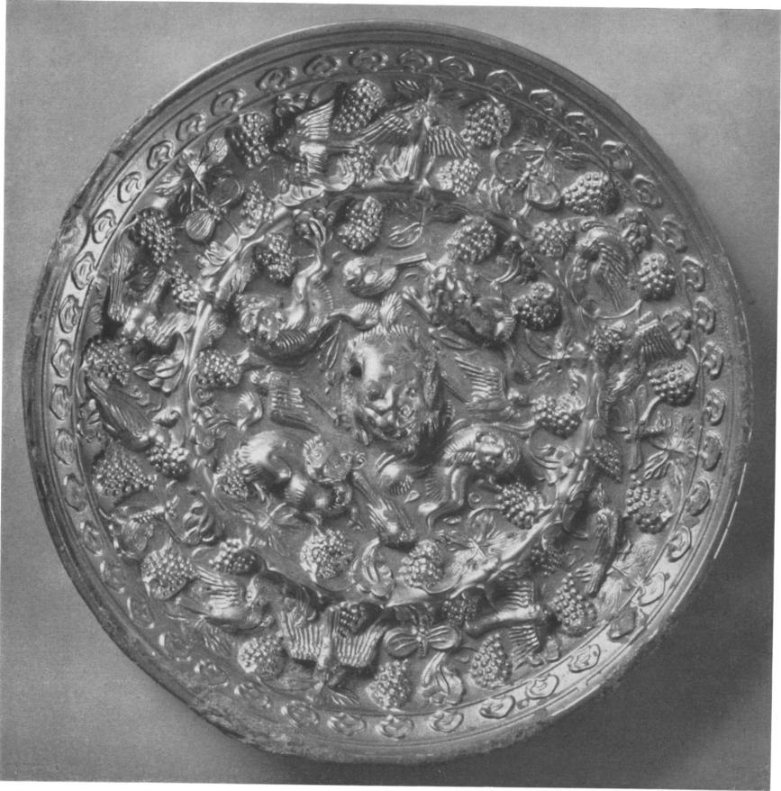

Fig. i Typical Tang grape pattern mirror with five lions  
*Collection of Richard* C. *Bull*

the rest in this series, whether or not they contained horses in their designs.' As it hap­pened he was unable to identify the horses correctly, either.

The winged horses on the Tang mirrors were intended to represent the "Heavenly horse", or *Then ma,* of old Chinese folklore,' but by Sung times this creature had passed out of Chinese tradition, and its place had been taken by the "Sea horse", or *Hai ma,* which had recently come into Chinese tradition from the Near East.' These were pictured as flame-decked stallions, apparently deriving from late representations of the *Pien ma* on some of the 'rang grape mirrors. Thinking in terms of his own times, the compiler of the imperial catalogue decided that the horses on the two fine grape mirrors were Sea horses, and accord­ingly he called them "Han Sea horse and grape mirrors", *Han hai-ma p`u-teao chien.9*

Although the Sea horse was still a distinct rarity in Sung art, it became a frequent motif in later dynasties, achieving special prominence in the Ming and Ch'ing.' The later scholars must have seen that this familiar horse symbol had nothing in common with the highly conventionalized animals which served as the principal features on the grape mirrors —namely the still unrecognized lions—and was therefore inappropriate for naming them.

6 *ibid., 29ff.*

7 For a good poetical description of the traditional Heavenly horse, see the Tang poem by Li Po in *Tu­shu chi-ch'eng (Chung-hua sku-chu* ed.), *chrin-a zing tien* 95, pp. 56-56b.

8 The description of the Sea horse in the *San-tsai u-hui , Niao-skou,* 3.5 b, implies that the *Hai ma* had already been mentioned in an ancient classic, the *Shan-hai eking.* Actually that reference only mentions a horse-like animal in the northern seas, without being at all specific. It would seem that the name *Hai ma* did not appear until Sung times, although legends regarding such a beast had gradually been accumulat­ing. A typical legend appears in the *Sui situ (Szkpu pei-yao* ed.), 83. lb. (All references to the Chinese dynastic histories are taken from this edition). Other legends regarding water horses can be found in Ishida Eiichiro's monograph, "The *Kappa* Legend", *Folklore Studies,* Vol. 9 (Peking, 1950), esp. pp. 3-13.

9 *Po-ku t`u-lu, 29.* 29 ff. The preface to the mirror section of this work refers to the *T'ien ma* in another connection, and the failure to associate this name with the horses on the Tang grape mirrors seems especially unaccountable in view of the fact that it was traditionally applied to the semi-fabulous Bactrian horses, usually linked with the coming of grapes in the accounts of Chang Chien, to whose time the Sung scholars attributed these mirrors. Cf. The *Tang hui-yao* 95. 3.

1° The popularity of the Sea horse motif on porcelains, etc., seems to have begun in the Yuan dynasty; but in the Ming and Ch'ing dynasties it had a special use as a designation of rank on the insignia for ninth rank officials. See S. Cammann, "The Development of the Mandarin Square", *Harvard ,journal of Asiatic Studies,* Vol. 8 (1944), pp. 77, II°, and Fig. II b.

However, in changing the designation, they apparently felt that tradition still demanded the word for "sea". Thus, when the Ch'ing Palace Collections were catalogued in the 18th century, these mirrors were called "Han sea-animal and grape mirrors"." In spite of this, the earlier expression, "Sea horse and grape mirrors", persisted on into recent times, to puzzle and confuse the Chinese antiquarians.

The Europeans were no less bewildered by it. Early Western students of Chinese mirrors concluded that the word for "sea" must have been used in an alternative sense, meaning "foreign", since the patterns seemed so "un-Chinese" in feeling. Several agreed that the pattern must have sprung from Hellenistic influences that supposedly entered China in Han times, and they even decided that the lion was used on them as an attribute of Dionysus.' Later, it was eventually recognized that these mirrors could not have come from the Han, and were probably from the Six Dynasties or the rang." Whereupon other non-Chinese scholars tried to compare their patterns of lions and grapes to the somewhat similar motives carved on the facade of the Mshatta Palace which was erected in far-off Syria sometime around the 8th century," but they could not explain why it was used.

There is no doubt that the ultimate origin of the grape vine motive lies far back in the Near Eastern or Classical worlds, as was conclusively shown by Hamilton Bell." However, the reasons for its use apparently sprang from influences nearer at hand.

11 See the *Hsi Ching ku-chien,* ch. 40, and the *Hsi Ch'ing hsii-chien,* ch. 20.

12 See, for example, Hirth, *Fremde Einfiiisse,* pp. 12-28, and Yetts, *Symbolism in Chinese Art,* London, 1912, p. 26. Hirth, in attempting to prove a Dionysian or Bacchic origin, even suggested that the Chinese name for the grape came ultimately from the Greek, and that the name of the Sea horse, *Hai ma,* had been selected to designate these mirrors in an effort to reproduce the word *haoma,* referring to the sacred plant of Persia and its brew. These contentions were both finally disproved by Pelliot in his above-mentioned review in *Tozing Pao,* 1921, pp. 143-45.

13 **J**apanese scholars first recognized that the grape pattern mirrors were not from the Han; but they did not know that they were rang, and ascribed them to the transitional period in the Six Dynasties. See, for example, Okakura Kakuzo, "Chinese and Japanese Mirrors", *Bull. of the Boston Museum of Fine Arts,* Vol. 6, no. 32 (April, 1908), pp. 9-14. Berthold Laufer passed on this later attribution to the West, in his book *lade,* Chicago, 1912, p. 14. The overwhelming reasons for assigning a rang date were finally conclusively ad­vanced by Hamilton Bell, in "Chinese 'Grape and Sea-horse' Mirrors". 14 See Bell, *ibid.,* p.62, and Yetts, *Cull Bronzes,* p. 169ff. Yetts does not seem to have known Bell's article, and he repeats some of the same ideas previously expressed by Bell, without developing them as fully. 15 Bell, *ibid.,* pp. 59-62.

We shall see that the Yang grape patterns probably originated partly in ideas and motives borrowed by the Chinese from Central Asia, and partly in indigenous Chinese concepts; and also, that— like most other Chinese mirror patterns — these were far more than mere decorations, and must have had deep symbolic meanings. We shall endeavor to dig these out while tracing the origin and development of the basic patterns.

II

The first Chinese mirrors with lion-like creatures in their decoration belonged to a Taoist type in use during the period of the Three Kingdoms and the Six Dynasties (220-589 A. D.). The patterns on these showed the World-mountain at the center of the Earth, represented by a very prominent boss, with seated gods at the four sides of the mountain and large monsters rearing up in the four spaces between them." Rare examples show the animals alone, without the gods." These monsters typically had catlike bodies equipped with wings, and generally had horns on their heads. In short, they were a kind of chimera, probably ultimately of Persian origin. These Chinese called them *Pi hsieh,* meaning "averters of evil", and they were obviously included in this capacity on these particular patterns, as symbolic guardians of the holy mountain. Figures of *Pi hsieh* were used quite extentively in the arts of that period as guardians for tombs and other monuments." However, by the end of the Six Dynasties, these monsters had fallen out of favor, and it seems probable that they had no connection with the true lions on the Yang grape patterns, which they only distantly resemble.

Real lions make their first appearance on a series of cosmic mirrors which date from the Sui  
(or perhaps the very end of the Six Dynasties) extending into the Tang—from about 590  
to 65o A. D. They quite commonly occur in a design that is clearly a survival of the so‑

16 A series of fine Six Dynasties mirrors with the chimera-type monsters are pictured in Florance Waterbury, *Bird Deities in China,* Ascona, Switzerland, 1952, plates 54-58.

17 The Boston Museum of Fine Arts has two examples showing the monsters without the gods (nos. 08.460 and 20.733), while the Fogg Museum, Cambridge, Mass., has another odd example on which the monsters and the gods are arranged in confronting pairs, instead of alternating around the boss in the usual fashion (no. 09.340).

18 The University Museum, Philadelphia, has two fine sculptured chimeras from the Liang dynasty. See  
Horace Jayne, "The Chinese Collections of the University Museum", "Philadelphia, 1941, Figs. 1 and 3.

called "TLV" pattern, which was so frequently found on cosmic mirrors of the Han dynasty, especially popular in the first century of our era." See Fig. 2. The later cosmic design still preserved the basic framework of the old Han pat­tern, which had represented a plan of the universe as it was then conceived. China — considered as the "Middle Nation" — was symbolized by a central square set within the cross marked off by the V-shaped angles; while the arms of the cross apparently stood for the four quart­ers of the world beyond China. 20 To emphasize the latter point, the four pro­jecting arms were often specifically label­led by figures of the Four Spirits which traditionally presided over the four direc­tions (see Fig. 3). 21 In the Han these creatures had figured on the pattern as rather small and unobtrusive, but now they were very boldly rendered. Finally, the cosmic character of the pattern was

19 See S. Cammann, "The TL V ' Pattern on Cosmic Mirrors of the Han Dynasty", *journal of the American Oriental Society,* Vol.68 (1948), pp. 159-167.

20 *ibid.,* pp. 161-62.

21 See S. Cammann, "Chinese Mirrors and Chi­nese Civilization", *Archaeology,* Vol. 2 (1949), p: 116 and Fig. 4.

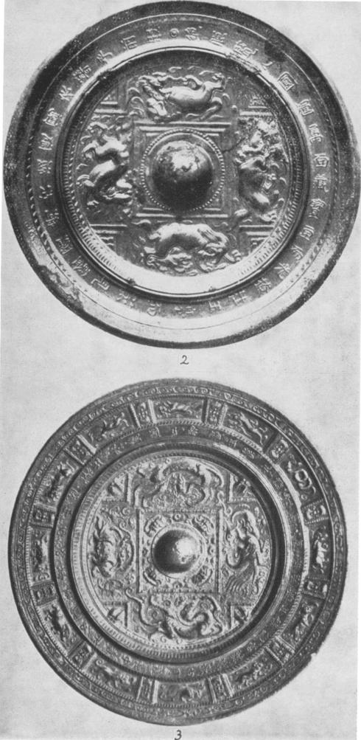

Fig. 2 Sui-T ang Four-lion mirror  
with remnants of Han *TLV* design  
After Swallow

Fig. 3 Early T rang "Four Spirits" mirror with signs of the zodiac  
Formerly in the *H. Ginsberg Collection, Berlin*

still further emphasized on many Sui and early Tang examples by the addition of the twelve animals of the Asiatic zodiac, which now replaced the twelve archaic characters that had ap­peared on many Han " TLV " mirrors. See Fig. 3. The twelve animals were used for the same purpose as the earlier characters, to symbolize the twelve double-hours of the day, the twelve months of the year, and recurring years in the sixty-year cycle. Their usage gave these symbols a semi-religious import, so they were not displayed without good reason. When employed to complete a cosmic diagram, they added the concept of Time to that of Space already conveyed by the basic pattern."

As a variation on the Sui-rang universe mirrors, the Four Spirits, which marked the four directions of space, were often replaced by lions, as we have seen, while a fifth lion some­times projected from under the boss." It seemed tempting to suppose that these might be lineal descendants of the guardian chimeras of the preceding period, but some passages in the 'rang dynastic histories have revealed their true identity, and indirectly explained why they could be substituted for the Four Spirits as directional symbols. These sources stated that the "Dance of the Lions of the Five Directions", accompanied by the "Music of Universal Peace", was a popular musical performance at the Chinese Court during the Sui and the 'rang." It had apparently been introduced from Kucha in Western Turkistan by a Kuchan orchestra which arrived in China in the latter part of the 6th century, in the entourage of a princess from that state who came to marry Emperor Wu of the Northern Chou dynasty in 568. The first performance of the dance was given in 577."

One account of the dance explained that the five huge lion figures — each activated by twelve men—were each given the color appropriate to one of the Five Directions (north, south, east, west, and center);" and along with the colors they would undoubtedly have

22 See *ibid.,* p. 117, and C. A.S. Williams, *Outlines of Chinese Symbolism,* Peiping, 1931, p. 379.

23 An example showing the fifth lion under the boss is illustrated in Hsu Nai-ch'ang, *Hsiao-tan luau-shih ching:ying* (1932), 4. 1 b.

24 *Hsin rang-shu* 21. 7. Possibly the peace song quoted in the *Sui shu,* 15.14b, may have been the one connected with the five-lion dance

25 See Sylvain Levi, *"Le Tokharien B,' langue de Koutcka", Yournal Asiatique,* Series II, Vol. 2 (1913),  
PP. 348-49. 26 *Hsin rang-shu,* 21.7. See also note 54, below. The traditional Chinese colors for  
the directions were : black for north, blue for east, red for south, white for west, and yellow for the center.

shared all the other associations of the Five Directions. Thus they would also have represent­ed the seasons, the Five Elements, and the Five Planets, etc., just as the Four Spirits had done." (Although there were only four of the latter, the mountain-boss had stood for the fifth element, Earth.)

Since the lions of the dance were also directional symbols, they could very naturally have been interchanged with the Four Spirits on the cosmic mirrors. However, it was a difficult problem to show the fifth lion, as long as the very prominent boss was considered symbolic­ally necessary to mark the World-mountain at the axis of the universe; and in any case the boss would have stood for the fifth element. This explains why number five was either represented as sprawled beneath the boss, or else omitted entirely.

In cases where the cross-shaped aspect of the universe design was not emphasized by the inclusion of "V's", four or five lions, or sometimes even six or eight of them, were shown encircling the central boss." The larger combinations can also be explained as directional symbols, because, once it became a convention to represent directions by lions, these animals could be used to symbolize other directional groups, such as the Six Directions *(liu-ho),* comprising the four cardinal points with the center of the Earth and the zenith of the sky; or the Eight Directions *(pa fang),* consisting of the four cardinal points and the four intermediates (northeast, southwest, etc.). Once again, the additional presence of the Twelve Animals on some of these mirrors makes it clear that they were actually cosmic diagrams and not mere decorative patterns. See Fig. 3.

III  
The concept of lions of the directions, and especially the Lions of the Five Directions, on  
cosmic mirror patterns leads us directly to the 'rang grape design mirrors, which succeeded  
as the next important type, probably sometime after 650." The purest type, and undoubt‑

27 See "Chinese Mirrors and Chinese Civilization", p. 116.

28 See R. W. Swallow, *Ancient Chinese Bronze Mirrors,* Peiping, 1937, Fig. 31, four lions; Fig. 63, five lions; Fig. 602, eight lions (probably dated too early). The collection of Raymond A. Bidwell, Springfield, Mass., has one with six lions.

29 The mirrors of the Sui-Tang cosmic type with the remnants of the "TLV" pattern were rarely dated, but one surviving example bears a date equivalent to A. D. 650, showing that this type lasted on until at least the middle of the 7th century. See Chen Pao-shen, *Ch'ing-ch'iu-kuan chi-chin t`u,* 70 b.

edly the earliest stylistically-speaking, showed five small lions in the central field. The fifth was placed directly in the center, taking the place of the old boss, and its body was arched to form a loop for the cord handle, which had formerly been attached through the holes in the boss. Although this mid-rang pattern is much freer than the earlier ones which bore the remnants of the old Han pattern, there can be no doubt that the animals on these were again the lions of the Five Directions, which still figured in the contemporary musical performances.

Some Japanese and 'Western scholars have implied that this fully developed pattern of lions and grapes originated in the Six dynasties." It is chronologically possible that the pattern could have begun to develop slightly before the end of that period, since we know that the dance from which it seems to have been derived was introduced to China before the beginning of the Sui. However, the general exuberance of the overall pattern, and some of its other elements, seem more characteristic of the *Zeitgeist* of the middle rang, in the late 7th and 8th centuries;31 and the Dance of the Lions of the Five Directions continued to be performed for many generations. —One of the Yang biographies discusses preparations for a performance of it in the year 821."

Quite apart from a probable esoteric meaning of the lion and grape motive, which we shall discuss later, there was a good reason for the popularity of the dance, and hence for the use of the lion pattern on the mirrors during the Sui and the early rang. After regaining national unity in the Sui, and a stable economy in the early rang, the Chinese had finally emerged from some four centuries of civil wars, foreign invasions, and general chaos. Therefore, the concept of a world at peace, and symbolic depictions of the same, would have been especially acceptable to them.

The other elements in the lion and grape patterns, such as the profusion of the grapes  
themselves, would have contributed to this form of symbolism, as well. The rang Court  
imported new kinds of grapes from Central Asia, and about the year 640 learned from the

30 See note 13, above, and Yetts, *Cull Bronzes,* p. 169.

31 Hamilton Bell concluded that the earliest of the grape mirrors must date from the 7th century. See Bell, *oft. cit.,* p. 66.

32 *ChinTang-shu,* 167.2, biography of Chou Tsung-ju.

people of Turkistan the art of fermenting them to make wine." Thus, grapes then became symbols of luxurious eating and drinking, making them fitting representations of the riches and plenty that would accrue in times of universal peace.

Even the outer elements of the pattern contributed to this sort of symbolism. The birds which ornament the outer ring on the earlier, basic type of lion and grape mirrors have long wedge-shaped tails which identify them as Chinese orioles. This particular bird, with its vivid yellow color and its rich song, was especially popular in China at that time as a symbol of music and joy." Because of its brilliant coloring, the Emperor Hsiian Tsung called the oriole "the little gentleman in golden clothes"," and many contemporary worthies wrote poems in its praises;" while its reputation as a natural musician caused it to be used on the badges for the Imperial Musicians down to the early zo th century." In addition to the appropriateness of having such a musical bird on a pattern which had apparently been suggested by a musical composition, the oriole was also used in the rang as a symbol of happy marriage, because tradition said that the male and female always flew together in happy pairs." — They are generally shown in pairs on these mirrors. For all these reasons, the orioles would have helped to carry out still further the concept of exuberant joy in a happy and harmonious universe.

The birds were generally separated from the inner zone which held the lions by a sharp, narrow ridge, or by a circle of vine stock, quite naturalistically rendered. But sometimes the orioles invaded the central field as well, flying among the lions, as in Fig. 1.

As further proof of the auspicious nature of the lion and grape patterns, many mirrors have other forms of lucky birds, supernatural animals, and even butterflies, along with the grapes

33 Laufer discusses the introduction of wine-making to China in *Sino-Iranica,* Chicago, 1919, p. 232.

34 Many references to the auspicious connotations of the oriole in China are cited in the *T u-shu chi-cCing, Ch` in-ch'ung tien,* 26, pp. 12b-16.

35 See the *Pen-ts` ao kang-mu,* 49.7

36 The tang poet Po wrote a very touching poem about an oriole, while in exile. This is translated

by Arthur Waley, *More Translations from the Chinese,* New York, 1937, p. 65.

37 See S. Cammann, "Chinese Mandarin Squares", *Bulletin of the University Museum,* Vol. 17, no. 3 (Philadelphia, 1953), Fig. 29.

*Pin-tscao hang-mu,* 49.7.

in the outer ring — although we shall see that these were generally introduced for special symbolic reasons. Moreover, occasional examples have the Twelve Animals of the Asiatic Zodiac circling the outer ring in place of the birds and other animals, signifying the orderly progress of the hours, months, and years, in a harmonious universe (See Fig. 6).

These mirrors generally have, around the outer ring of birds or animals, a narrow bordering band. On many of the earliest examples this is decorated with small, tight cloud scrolls, to indicate the rim of the encompassing dome of the sky, which was considered as fitting down over the earth (See Fig. 1). These lion and grapes mirrors, then, were cosmic ones, springing from the same basic tradition that had inspired the "TLV" patterns of the Han, even if some of the elements in their design were of more recent foreign origin. However, the very freedom and exuberance of the Yang patterns makes it difficult to realize their relationship to the formally-conceived ones of the Han, on which hard, angular lines so firmly delimited the outlines of the universe.

IV

The original conventional placing of the five lions on the grape mirrors, with the fifth occupying the center, maintained the long tradition of four-part symmetry in design, which up to this time had predominated in Chinese mirror patterns — in spite of occasional digressions along other lines. However, the mid-rang metal casters were working for an exceedingly wealthy clientele who must have appreciated novelty, and this undoubtedly accounts for their subsequent attempts at variations on the main theme.

By juggling with the problems of symmetry, and striving to express alternative directional concepts with other combinations of lions, the metal workers produced great diversities of pattern based on the original lion and grapes theme. The simplest variation showed the five lions arranged in an X-pattern instead of the usual cross." The cross was the natural way to indicate the directions of space, but if the lions were representing the Five Elements, or some other symbolic combination of five implicit in their symbolism, the actual placing would not much matter. Fig. i shows an example of this.

Another simple variation showed the five lions coursing around a plain boss, while the birds  
or animals in the outer ring were usually increased to ten, in order to achieve a five-part

39 Several examples of both types are shown in the *Hsi Ch'ing ku-Chien,* ch. 4o.

symmetry." Then, either to represent the Six Directions (as discussed above), or to ornament still further the center of the mirror, a sixth lion was added to form the arched boss so character­istic of this style of mirror." — In fact this form of boss was so popular at that time that lion bosses were used on various other types of 1' ang mirrors as well, as shown in Fig. 5.

Fig. 4  
Miniature T rang grape mirror with pattern inset in gold  
*Winthrop Collection, Fogg Museum of Art*

Fig. *5*  
Middle Tang " mariage mirror" with lion-boss and peacocks  
Courtesy of *Boston Museum of Fine Arts*

Others of these mirrors have six lions running around a plain boss, with the animals in the outer ring generally in­creased to twelve. Then we find six grouped around a seventh which forms the boss. (See Fig. 7). It would appear that the seven were deliberately placed this way — rather than resulting from the addition of a lion boss to the lions of the six directions — for this com­bination is very commonly found. 42 But it is very difficult to assign them to any scheme of directional symbolism, unless perhaps the seven lions could have represented the four cardinal points horizontally, and the axes of

40 *ibid.,* p. 2, shows a typical example, with the zodiac animals in the outer ring.

*41 ibid.,* pp. 3, 4, 5, etc.

42 Six examples of the seven-lion combina­tion are shown in *ibid.,* p. 14ff.

the three worlds (an idea introduced to China by the Buddhists)," vertically. However, they could also have been used to express two related concepts which we shall discuss later in connection with the third level of symbolism in these patterns (in section VI).

The Eight Directions were represented by eight lions running around a plain boss, as on the earlier type of Sui-rang mirrors (see Fig. 6); and when the lion-boss was added to make nine of them, the resulting pattern would have represented the Nine Directions: the four cardinal points, four intermediates and the Center. Again, this combination is capable of being explained in another way as we shall see in section VI." There were never more than nine adult lions in the central field of these mirrors; but, as we shall see, cubs were often added to complete the symbolism implicit in the next group of the lion and grapes mirrors.

V

One of the more popular categories of mirrors in the middle and later Tang were the so-called "marriage mirrors", which in themselves were capable of interpretation on several levels of meaning, in addition to the obvious wedding symbolism." These usually had a pair of auspicious birds — such as the exotic peacocks or parrots, which were then making their first appearance in Chinese art along with the newly-introduced grapes" — or a pair of mythical animals, like the Heavenly horses or the horned lions called *suan-i,* confronting each other from opposite sides of the boss. Smaller, related symbols filled the empty spaces

43 The concept of the Three Worlds was not confined to Buddhism. This term also appears in Manichean writings, although it is not yet clear whether or not it might have had a somewhat different meaning there. See Chavannes and Pelliot, a *Un traite manichien retrouve en Chine),* Part I, *Journal Asiatique,* Series io, Vol. 18 (Paris, 1911), pp. 565, 586; Part II, *Journal Asiatique,* Series 11, Vol. i (1913), p. 102, text and note 2, and 135, note.

44 The nine-lion style is fairly rare, but there are no less than three of these mirrors in the 8th century  
Japanese collection in the ShosOin treasury at Nara. See the *Shosain gyobutsu zuroku, V 01.14,* nos. 40-42.

45 See S. Cammann, "A Rare Yang Mirror, *"The Art Quarterly,* Vol. 9 (Detroit, 1946), p. 108, second  
paragraph, and 109, final paragraph. See also "Chinese Mirrors and Chinese Civilization", pp. 118 and 119.

46 There must have been some rather universal symbolic link between peacocks and grapes at this period, because they appear together in the contemporary arts of the Near East and Christian Europe. A good example of the conjunction of these symbols at that time is shown on the late 7th century sarcophagus of Archbishop Theodore, at *San Apollinare in Classe,* in Ravenna.

in the central field above and below them, but the greater prominence of the side figures inevitably created a bi­lateral symmetry highly appropriate to their symbolism.

7

Fig. 6  
Middle T rang Eight-lion mirror with animals of the zodiac  
Courtesy of the *Buffalo Museum of Sciences*

Fig. 7  
Tang square Seven-lion mirror in the Shosoin at Nara

This bisymmetrical "marriage mirror" concept even invaded the lion and grape patterns. A number of examples pictured in old Chinese catalogues of the imperial collections show pairs of peacocks or Chinese phoenixes includ­ed in the central zone, between the opposite pairs of lions, thus tending to split the basic pattern in two." However, the long-held tendency to­ward four-part symmetry often won out, and we sometimes find a hori­zontal pair of phoenixes balanced by a vertically-placed pair of dragons to form a second axis, set off by the four outer lions. 48 On other examples, a

47 See Liang Shang- ch'un, *Yen-ku-tsang thing 3.* 22, for a fine example with the five lions and two peacocks; another is shown in the *Chin shih so,* ch. 6a (no pagination). A rare example in the Metropolitan Museum of Art has two sets of birds—a peaocock and a Chinese phoenix, opposed to a Chinese phoenix and a peacock — between the outer pairs of lions on either side of the boss.

48 *Hsi Ch'ing ku-chien,* 4o. 31 and 32. An  
example in the Victoria and Albert Museum,

pair of birds or animals took the place of two of the five lions;" and on one type, the paired phcenixes and the dragons even replaced the four outer lions altogether, leaving only the central one which formed the boss." But even this latter, reduced version of the lion pattern was still a cosmic diagram, as it had in the outer ring the Twelve Animals of the Zodiac.

More often, the marriage concept was expressed in a simpler way by using only the five (or more) lions in the central field, but by including, in the outer band, pairs of the birds associated with matrimony—mandarin ducks, wild geese, and magpies, as well at the peacocks, phcenixes and parrots — and mythical animals such as the Heavenly horse and the Celestial deer *(rien-lu),"* or even other lions.' Sometimes, to round out the animate world, pairs of auspicious insects, butterflies, bees, and dragon flies, were shown as well.

On some of these lion and grape "marriage mirrors", the four outer lions of the inner circle were furnished with mates, making eight or nine in the center (see Figs. *6* and 8). As we have seen, this would not have violated the directional symbolism, either, because the eight could represent the Eight Directions, and the nine, the Nine Directions of Space. Furthermore, their cosmic character was sometimes emphasized by the Twelve Animals of the Hours, as shown in Fig. *6.*

We have already seen that nine was the maximum number for the principal lions in the central field of these patterns, but sometimes on these "marriage mirrors" the four pairs around the boss were also provided with cubs, to denote fertility. One extreme example from the 8th century collection in the Sh5s5in at Nara, in Japan, has nine adult lions and thirteen cubs, making twenty-two animals altogether, in the central field." This particularly

South Kensington, is depicted in S. W. Bushell, *Chinese Art,* London, 1914, Fig. 6o.

49 The *Chin shih so,* ch. 6, shows an example with two Chinese phcenixes and three lions; while the *Hsi ku-chien,* 40. 24, pictures one with two Heavenly horses replacing two of the five lions.

50 This one-lion type of marriage mirror with dragons and phcenixes is fairly common. The *Hsi Ch'ing ku-chien* illustrates two (40.33, 34); another is pictured in Swallow, Fig. 62; while still another, in the American Museum of Natural History, is shown in Bell's article, Fig. 3.

51 The Heavenly horse and the Celestial deer are usually shown in pairs, as illustrated in Fig. 8, upper right and lower left of the outer ring, implying that the latter must have been considered as a female, since the Heavenly horse was always a stallion.

52 *Hsi Ch'ing ku-chien,* 40.10 and 27. 53 *Shosoin gyobutsu zuroku,* 14.34.

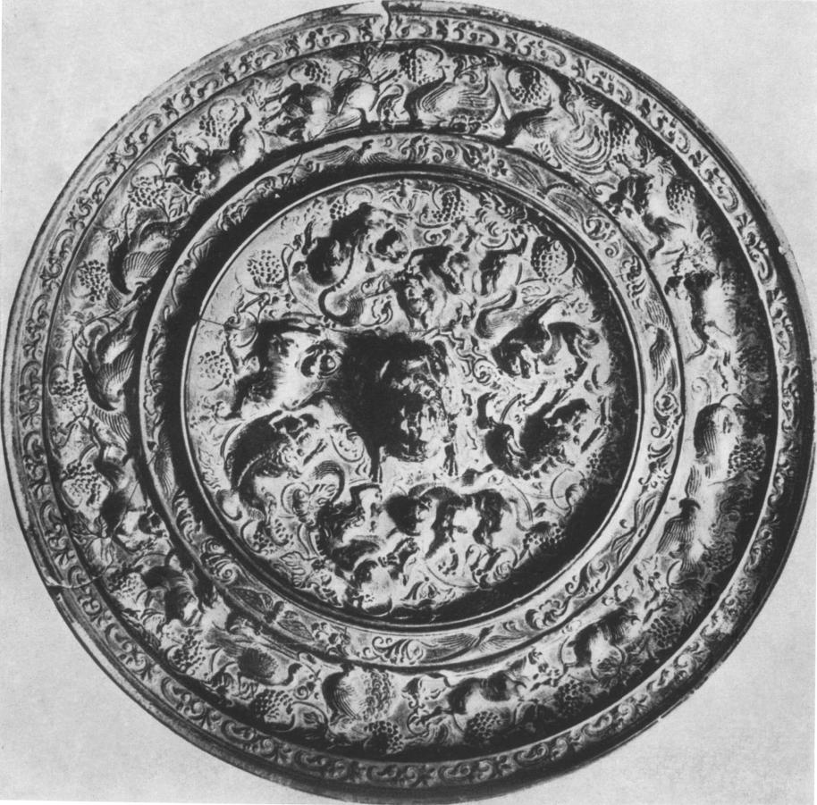

Fig. 8 Tang Nine-lion mirror, marriage type, with paired animals  
Courtesy of *Boston Museum of Fine Arts*

elaborate mirror would seem to be symptomatic of a late development in the total pattern, when it was gradually approaching the status of a decorative design expressing the exuberance of nature. But even in its extreme elaborations the lion and grapes motive never lost its original, very specific, concept of a balanced universe in harmonious relationship.

VI

The vogue for the Dance of the Five Lions must have begun to decline in the latter part of the 8th century. The Yang Court never did recover its equilibrium completely after An Lu-shan's rebellion of 755-763, and it no longer enjoyed such great wealth after the looting raids by the Tibetans and the Uighur Turks, who had taken advantage of internal strife to come in and pillage. Not only did the chaos of the times make peace seem a rather remote ideal, but there were fewer occasions of leisure in which to stage such a pretentious performance as the Dance of the Five Lions with its full complement of some 210 performers not counting the musicians.' Thus, the knowledge of its theme must have gradually been passing from peoples' memory. As previously mentioned, the last allusion to a performance of it dates from the year 821, and it seems to have disappeared completly some twenty years later, when a strong anti-foreign movement led to a violent purge of alien religions and their ceremonies." This dance, having been introduced from abroad, and apparently possessing religious overtones from a foreign faith— as we shall see —• would have doubtless fallen into one of the forbidden categories.

" The account of the Dance of the Lions of the Five Directions in the *Chiu r ang-shu,* 29.1, says that there were 140 men who sang the song of peace and danced with their feet, in addition to the sixty who activated the five ten-foot high lion figures (twelve men inside each one). It also speaks of two men who guided the lions with ropes and brandished red yak-tail switches to direct the motions of the dance, and although it is not entirely clear whether there were two directors for each lion, that would seem to be the case, making ten additional participants. The accompanying orchestra was also very large.

55 One factor which caused the Tang persecutions of 843-45 was a belated reaction of the conservative-minded members of the aristocracy against several centuries of foreign cultural-borrowing. However, the primary impulse was the fact that the Uighur Turks had given strong political backing to the Manichean faith, which had become their state religion in 762, forcing the Chinese Court to grant it many concessions; so that, when the Uighur state fell to pieces in 843, the Chinese decided to take advantage of the with­drawal of their support to get rid of the Manicheans permanently. Once the persecution got under way, it was soon extended to other foreign faiths, and by 845 a violent attack was launched against Buddhism,

It would seem that the tradition of the lion and grape mirrors, as well as the dance, must have come to an abrupt end after the persecutions of the mid-9th century. We have observed that the scholars of the next great dynasty dated these mirrors back to the Han, nearly a thousand years before, indicating that this pattern must have died out very suddenly sometime before the end of the rang, so that all tradition of their use had passed away by the i ith century." Moreover, since the lion and grape pattern was never revived in its proper form" — except by forgers wishing to deceive antiquarians and collectors who desired "Han" mirrors" —it would seem that the pattern had had no lasting significance to the Chinese themselves.

The sudden disappearance of both the cosmic dance and the pattern after the persecutions of 843-45 would suggest that they had both probably had some connection with an out­lawed foreign religion. There is no apparent trace of them in Nestorian Christianity or in Zoroastrianism, and if they had been Buddhist, some memory of them would have been preserved by the later Buddhists, who gradually won their way back to official recognition. The common, small lion dance, which was also performed in the Tang and has survived into modern times especially for New Year's celebrations, has been called Buddhist; but this does not contain the same implications of cosmic symbolism and it appears to have had a

Nestorian Christianity and Zoroastrian Mazdaism. See Chavannes and Pelliot, t *Traite manicheenD ,* Part II (1913), PP. 284-303.

56 Aside from one or two occurrences of grapevine *rinceaux* in the borders of Tang stone monuments preserved at the *Pei lin* in Sian, Northwest China, the only other surviving use of the grapevine motif from that period in the whole of the Far East seems to be the *rinceau* pattern on the bronze throne of the image of Yakushi, Buddha of Medecine, in the Yakushiji at Nara, in Japan. Dedicated in 716, this is said to have been designed and cast by bronzeworkers from rang China. A possible reason for its appearance there will form the subject of another article.

57 During recent centuries—in the late Ming and Ch'ing dynasties —there was an attempt to revive the old grape motive as a subject for nature paintings or as a border design, in woodwork, etc. But the overly-conventionalized lions were completely misunderstood, and they were rendered as squirrels, rats, or even mice, scampering among the grape leaves.

58 The T'ang grape mirrors have probably been the most frequently counterfeited of any Chinese bronze mirrors. The later imitations can usually be quite easily recognized by their faulty, or un-crisp casting, and by the use of too-reddish alloys, indicating a higher proportion of red copper than was cusomarily used for the originals.

separate origin." There is a world of difference — involving far more than degree of simplicity— between the simple mask-dance or mime, performed by two men under an imitation lion skin to the sound of a drum, and the highly elaborate "Dance of the Lions of the Five Directions", with its huge puppets and its small army of dancers, singers, and musicians, forming a great operatic pageant full of cosmic imagery. The first is merely a variation of a primitive dance-form found all over the world, while the cosmic opera was a product of a highly advanced culture.

Since the Dance of the Five Lions and the mirror pattern were neither Christian, Zoroastrian, nor Buddhist, they must have had some connection with fourth great foreign faith of 'Pang China that was forcibly suppressed in 843. This was Manicheism, that strange and wonderful "Religion of Light"," which, in the course of a few centuries extended its sway from Babylon to the Atlantic Ocean and to the China Sea, gaining such illustrious converts as the youthful Augustine, the Khaghans of the Uighur Turks, and the Counts of Toulouse, before it sank back into darkness and oblivion."

59 One of these small lion dances, acted out by two "barbarian" youths to the beating of a drum, is described in an early 9th century poem by Po Chu-i, which can be found in the *Ch` iianTang-shih lu,* 62.17, showing that the small-lion mimes and the Dance of the Five Lions were both present in Tang China at the same period.

Laufer, who apparently did not know about the latter spectacle, described the simpler type using one or two two-man lions, in "Oriental Theatricals", a Field Museum Guide, Chicago, 1923, pp. 29-3o. He ascribed its origin to a form of Indian mime or burlesque juggler who originally wandered about exhibiting tame lions and trained monkeys at market fairs and religious festivals to entertain the crowds. See *ibid.,* and *Chinese Pottery of the Han Dynasty,* p. 241, note.

6° The almost forgotten religion of Manicheism has been quite fully described by F. C. Burkitt, *The Religion of the Manichees,* Cambridge, England, 1925, and by H. C. Puech, *Le Manichiisme,* Paris, 1949. Its Chinese form is very fully discussed by Chavannes and Pelliot in I *Traite manicheen,,* and in more popular form by T. A. Bisson, "Some Chinese Records of Manichaeism in China", *The Chinese Recorder* Vol. 6o (Shanghai, 1929), pp. 413-428.

61 There is still some question whether the mediaeval Bogomils of southeastern Europe and the Albigensians of southern France were actually Manicheans. Steven Runciman, who described both of these sects very interestingly in *The Medieval Manichees* (Cambridge, 1946), is inclined to think that they were merely gnostic heresies within Christianity, but then he classed Mani himself as a heterodox Christian *(ibid.,* p. 12). However, most other writers on this subject seem to agree that the Albigensians and their leaders among the French nobility of Provence were true Manicheans.

Manicheism was not formally introduced to the Tang Court until 694." But there must have been many foreign Manicheans in China before that time, and Manichean influences could already have been widely diffused by merchants and travellers from Persia and Central Asia. The kingdom of Kucha, from whence came the orchestras which introduced the Dance of the Five Lions to the Chinese, was traditionally Buddhist." And yet, as one of the more westerly caravan centers of Chinese Turkistan, on the northern road from Persia to China, it was open to influences from Persia which had been one of the first strongholds of Manicheism; and it had doubtless provided refuge for the Manicheans who had fled east out of Persia to escape from the fanatic Zoroastrians, even before the final expulsion by the followers of Islam." Very significantly, the Kuchan musicians who were performing in the Chinese Court at the beginning of the 7th century included in their repertoire an operatic selection called "The Good, Good Mani Expounding"," while several of the other titles which have been preserved seem capable of explanation in Manichean terms."

We know too little about the beliefs of the Manicheans in China to tell precisely whether their ritual or symbolism contained the idea of lions for representing the directions of space.

62 *Traite manicheen2 ,11* (1913), pp. 150-51.

63 Levi, ,K *Tokharien Be,* pp. 333ff. describes some of the Buddhist activities in mediaeval Kucha, as well as detailing the life-story of the Kuchan prince, Kumarajiva, who played an important role as a Buddhist missionary in China during the Six Dynasties period.

64 The first persecution of Manicheism in Persia immediately followed the martyrdom of Mani, which modern scholarship has determined must have occurred in A. D. 277; see Puech, *Le Manicheisme,* pp. 5 2, 57. However, by about 63o it had revived sufficiently so that the Chinese Buddhist pilgrim, Hsuan-tsang, reported its sanctuaries in Persia, in what is thought to be the first Chinese reference to the Manicheans; see *eTraite manichien» ,11 (1913),* p. 150.

65 This performance by a Kuchan orchestra is referred to in the *Sui shu, 15.18b,* and in other sources. Chavannes and Pelliot have suggested that the word transliterated as *ma-ni* might be referring to the *mani* jewel of Buddhism; see «*Traite manichien»,11 (1913),* p. 150, note 1. However, they had already pointed out that the word *span,* which is twice repeated before that word, had a special technical significance in Manicheism, referring to luminosity *(ibid., I* (1911), p. 532, note 2), in which case, it would have been especially suitable to describe Mani, who was frequently characterized in Manichean texts as the "Mes­senger of Light". As a modifier of the word for jewel, *than* would not make much sense.

66 The rest of the Kuchan repertory in early 7th century China is related in greater detail in a Sung work, the *rung-chih* by Cheng Mao, reprinted in the *ru-shu chi-ch'eng, Yiieh-lu lien,* ch. 76, p. 64.

However, we have seen that the Chinese directional animals could also represent the Five Elements, along with the Five (principal) Planets, etc.; and the frequent arrangement of the five lions in an X-pattern, instead of the directional cross, indicates that they must have been representing something other than the directions. A suggestion is provided in the fragments of Manichean texts recovered by Aurel Stein and Paul Pelliot from the Tun­huang caves in Northwest China. Like the Manichean texts found elsewhere in Asia, these stress the importance of the Five Elements in that faith. Manicheism emphasized the bitter conflict between Light and Darkness in the universe, and the Five Elements were intimately associated with the forces of Light." For example, they are commonly referred to under such names as "the Five Bodies of Light"."

In Western Asia, lions had long been considered as solar animals, representing the power and glory of the sun, and Tang literary references show that they were also associated with light in China. Contemporary descriptions refer to them as having brilliant coats and eyes that flashed like lightning." It seems quite possible, then, that the five lions on the grape mirrors — being both symbols of the Five Elements, by extension, and creatures of light —could have represented the "Five Bodies of Light" in Manichean cosmology. It is also pos­sible that the Chinese may have failed to understand completely all the connotations of the lions in this foreign dance, and that they therefore could have emphasized the directional interpretation of their symbolism, neglecting the other aspects.

The use of the five lions to represent the Five Elements would also tend to explain the meaning of the dance, about which very little definite information is given. The old Chinese records merely tell us that it was a dance of universal peace, involving directional lions and numerous other performers, without explaining much of its significance. To turn again to

67 See Burkitt, p. 24; and for a detailed description of Mani's teachings regarding the battle between Light and Darkness, see Franz Cumont, *Recherclzes sur le Manicheisme,* I, Brussels, 1908, pp. 7-49, or, in more abbreviated form, Puech, p. 75ff.

68 c *Trade manicheen,1* (1911) pp. 513-14, text and note I : and Burkitt, p. 52, etc.

69 The *Tu-shu chi-ceing, Ch in-chrzing Lien,* ch. 59, p. 55, quotes the *Shu-i chi,* describing the lion's fur by the word *kuang,* meaning "luminous", an adjective constantly appearing in Manichean writings. Two Tang poets refer to its eyes as being "luminous as lightning", *ibid.,* p. 55 b, and variations on that expres­sion seem to have been common at that time.

Manichean teachings, the only way in which universal peace could be achieved, according to their doctrines, was by the final victory of the forces of Light, and the subsequent com­plete recovery of the Five Elements which had been partially lost to the spirits of Darkness." If the lions indeed represented the Five Elements, as seems likely, then their triumph in a cosmic dance would also have represented the ultimate victory of Light in the universe, according to the Manichean doctrine.

The fairly common use of seven lions on the rang grape mirrors could also be explained in terms of Manichean cosmology, in at least two ways. First, the number seven, like the number five, played an important part in the numerical categories of the Manicheans, and there were several groups of seven things." One of the chief of these was the "Seven Elements", composed of the usual five, together with two other legendary beings of light (Khro§tag and Padvakhtag);" and the seven lions as symbols of elements could have stood for these. Secondly, we have seen that the Chinese used the symbols of the directions to stand for the Five Planets, as well as the Five Elements, and in this case, too, an extension was possible. The seven lions as symbols of the heavenly bodies could have represented the "Seven Luminaries": the usual five planets together with the sun and the moon." This grouping was also an important one to the Manicheans, and Chinese records give evidence that Central Asian Manicheans introduced into Tang China the seven-day week based upon this concept, with the name of one of the "Seven Luminaries" assigned to each day of the week." Thus the seven lions as representations of the "Seven Luminaries" would have stood for heavenly forces, bodies of light, and units of time, simultaneously.

In fact, the seven lions could have stood for both the Seven Elements and the Seven Luminaries at the same time; just as the five lions might have represented both the Five Elements and one of the other Manichean groupings of five bright things, such as "the five

70 Burkitt, p. 24ff.

71 For the importance of the number five in Manicheism, see .z *Traite inanichien»,1* 0914 p. 526, note 5; and for the number seven, see *ibid., 11 (191*3), p. 191.

72 Chavannes and Pelliot discuss this group of the "Seven *Mahraspand"* in *ibid., I* (191 1), PP. 543-544, text, and note 1 of latter page; and *ibid., 11 (* 1913), p. Ioi, discusses the word *Mahraspand* in the sense of "Element".

73

*ibid., 11* (1913), p. 171. 74 *ibid.,* pp. 161-62, 171 ff.

2 8'7

sons of the Living Spire." The Manichean teachings, like those of the Gnostics, character­istically employed several levels of meaning at once, so that a word or a symbol could mean one thing to non-believers, another to the "auditors", or ordinary followers, and would convey still more to the fully initiated "adepts "."

To continue our search for all possible levels of meaning, let us consider again the nine lions. We have seen that they could possibly have served as directional symbols, and certainly were often used as marital ones; but they could also have conveyed another Manichean concept as "beings of light", by representing the "Nine Luminaries". This was another foreign grouping introduced into 'Fang cosmology, consisting of the Five Planets with the sun and moon, and two legendary "planets", Rahu and Ketu."

With the grapes, we are on even firmer ground in the Manichean teachings. Their texts constantly refer to the "Fruits of Light", which formed the only suitable food for the ascetic adepts." The recovered fragments are not specific as to what kinds of fruits were included in this term. However, a mediaeval Manichean miniature, recovered by von le Coq in Chinese Turkistan, provides an answer." This painting, which is said to depict the "Manichean Eucharist", represents an offering of sacred foods before an adept, consisting of a bowl filled with melons and bunches of purple grapes." Therefore, in Manichean terms, the grapes on the mirrors would have represented the Fruits of Light.' — It is interesting

75 See Burkitt, p. 27, and A. V. W. Jackson, *Researches in Manicheism,* New York, 1932, PP. 296, 313.

76 See Runciman, p. 7. Although he is speaking primarily of the Gnostics, the same statements apply to the followers of Mani, who was himself strongly influenced by gnostic teachings.

77 <4 *Traite manicheen, II* (1913), p. 16o. The last two represented, respectively, the ascending and descending nodes of the moon.

78 See Puech, p. 90.

79 See A. von le Coq, *Die Buddhistische Spdtantike in Mittelasien,* Berlin, 1923, Vol. 3. The same picture is reproduced in Burkitt, facing p. 35.

80 Melons are known from other sources to have been among the special food of the elect; see Puech, *ibid.,* and t *Traite manichi'enz, , II (1913),* p. 341, note I. I do not recall ever seeing melons as such on these Tang grape mirrors, and it is probable that they were not used because they would be so bulky as to spoil the effect of the total pattern, but melon blossoms do occur. One example is shown on a variant Tang mirror among the more usual grape variety in the *Chin shih so,* ch. 6a, and two more are shown in

*Hsi Ch'ing ku-chien,* 40. 22, 24.

81 The concept of grapes as "Fruits of Light" may help to account in part for the great popularity of the

to compare this meaning with that provided by the first explanation of the pattern. To a Manichean, they would have been symbols of spiritual abundance, associated with the food of the learned ascetics, rather than symbols of material plenty derived from the food and drink of self-indulgent courtiers.

The vividly golden Chinese oriole was certainly associated with light. The Celestial deer, quite frequently found on these mirrors, is described as a creature of brilliance," and the Heavenly horse is depicted in mediaeval Chinese poems as streaking down through the clouds from the Sky Gate like flashing lightning." Both of these animals were often pictured with flames streaming from their withers. (In fact the flames eventually replaced the *Te ien ma's* wings, providing a transition into the Sea horse type of later times). The dragon flies might also have served as creatures of light, since one Chinese species is a very bright yellow, while the brilliantly-hued Chinese butterflies would certainly have fallen into this category.

Lastly, the Twelve Animals of the Hours (or the Zodiac), which occur on some of these mirrors, and formed the subject of another performance by the Kuchan musicians in 7th century China," were also associated with light in Chinese Manicheism. In fact, this religion greatly stressed their cult. The Pelliot text, for example, refers to them as the "Twelve Great Luminous Hours", or the "Twelve Luminous Kings"."

In view of the Manichean preoccupation with the luminous, it seems only natural that the Chinese followers of that faith would have used mirrors to celebrate the "religion of Light", since mirrors in general had been considered by the Chinese as associated with light, light­ning, and solar brilliance, for centuries before the -rang." Moreover, these particular mirrors which carried the lion and grape designs were composed of an exceptionally white alloy,

grape motive on Persian textiles and other art objects during the Sassanian period, when Manicheism for a time enjoyed state recognition under Shahpur I. 82 *Sung shu,* 29.22.

83 See the poem by Li Po of the Tang, referred to in note 7, above. 64 *Sui shu,15.18* b.

85 *Traite manicheenD,* I (19i I), Chinese text pp. 602, 600, and 593, (the numbering runs backward here),  
and translation pp. 565-567 ff. The translators do not seem to have realized that they were dealing with  
personifications of the zodiac symbols, and therefore the translation sounds somewhat confused in places.

86 The association of Chinese bronze mirrors with the sun and with light recurs constantly in Chinese allusions to mirrors, and is especially emphasized in the inscriptions on a whole category of mirrors from the Han and Six Dynasties period, namely the *Yih-kuang* type. See B. Karlgren, "Early Chinese Mirror Inscriptions", *(Bulletin of the Museum of Far Eastern Antiquities,* Vol. 6 (Stockholm, 1934), p. 26.

which made them among the brightest of all Chinese bronze mirrors, although special conditions of burial have since turned some of them black." The fact that this alloy was traditionally made up of five metals (though not always in the same combinations) would probably also have appealed to the Manicheans, with their fondness for groupings which involved the number five."

In short, both these mirrors and their symbolism would have been ideally suited to represent the tenets of the Chinese Manicheans. And it seems very likely that they did; since they flourished during the brief period when that religion was recognized in China, and died out at precisely the time when it was officially destroyed.

In spite of their apparent Manichean connections, though, not all of the Yang grape mirrors need to have been Manichean. Even if the basic pattern had been definitely inspired by Manichean beliefs, it could have been taken over by the sophisticated courtiers of the Yang purely for its decorative value. We have seen too, that, symbolically-speaking, the grape pattern in all its variations could have been interpreted in non-Manichean, even secular, ways by non-believers. While, in religious terms, the symbolism of an integrated universe would have been completely acceptable to the Taoists, or even the Chinese Buddhists —especially when the concept of Unity in Duality was clearly expressed, as it was on the "marriage mirror" variations." Indeed, the large number of lion and grape mirrors that have survived in China and Japan," even excluding the obvious later forgeries, would indicate that the pattern must have been highly popular in Yang times with many others besides the Manicheans, who were after all never too numerous in China. The point is that the mirror pattern probably never entirely lost its associations with the foreign religion

87 The so-called "black enamel mirrors" referred to by Swallow, p. 52, are the result of burial under moist conditions in a damp climate.

88 For this alloy, see Laufer, *Sino-Iranica,* p. 555. His information seems to clash with the analysis presented in Swallow, p. 65; but the example tested might not have been a typical one. For the actual techniques of manufacture employed in making the rang grape mirrors, see Bell, pp. 67-68.

89 See "A Rare Yang Mirror", page io8, second paragraph.

90 In addition to four outstanding examples in the ShOsein at Nara *(Sh6s6in gyobutsu zuroku,* Vol. 14, nos. 40-43), a number of other 'rang grape mirrors are set into the *tengai* on the ceiling of the Hokkedo at the Todaiji in Nara, but unfortunately only the reflecting surfaces are visible; see the *TOclaiji o-kagami II,* Plates 5 and 22. In this connection, see also Bell, pp. 63-64.

in people's minds, and thus it was still sufficiently related to that faith to have shared the fate of all things Manichean after the persecution of 843.

Official proscription drove the Manichean religion underground, where it existed rather precariously for generations, part of that time hiding under the cloak of Taoism." However, the later followers —even if they had possessed the wealth to enjoy the luxury of bronze mirrors, which most of them did not—could not have afforded to attract the attention of the authorities by the use of overt symbols that might too easily identify them. Meanwhile, non-Manicheans would likewise have avoided the use of an unpopular or even dangerous pattern. This may explain why the grape patterns were never revived.

*Conclusion*

We have seen that the lion and grape pattern on Tang mirrors was not merely a foreign design taken over completely from alien sources, as previous Western writers have tried to show. Apparently it was basically a symbol of the universe in microcosm, composed in accordance with China's great tradition of universe symbols — although it made use of two borrowed motives, the lions and the grapes. Like many rang patterns, this one was susceptible of several interpretations on different levels: a hedonistic one in keeping with the material outlook of the rang Court, a more idealistic one with reference to marriage and the family, and a rather esoteric one embodying the religious beliefs of a particular faith then current in China.

More specifically, the basic pattern would have represented to the Manichean believer a high concentration of accumulated light in a harmonious universe from which darkness had been banished. Certain of the more specialized examples would have conveyed an idealized picture of happy marriage, symbolizing the domestic universe in happy harmony. But, to most people of that time, the pattern would have depicted a cosmic plan of the universe at peace, representing graphically the same ideas as the Dance of the Lions of the Five Direc­tions accompanied by the Song of Universal Peace.

91 For the underground period of Manicheism, see < *Traite manicheem >,11* (1913), pp. 318-374. Some of  
the later connections between Manicheism and Taoism are discussed in more detail in *ibid.,* pp. 116-132.